ASSIGNMENT NO. 1

Que 1 : wap to print welcome

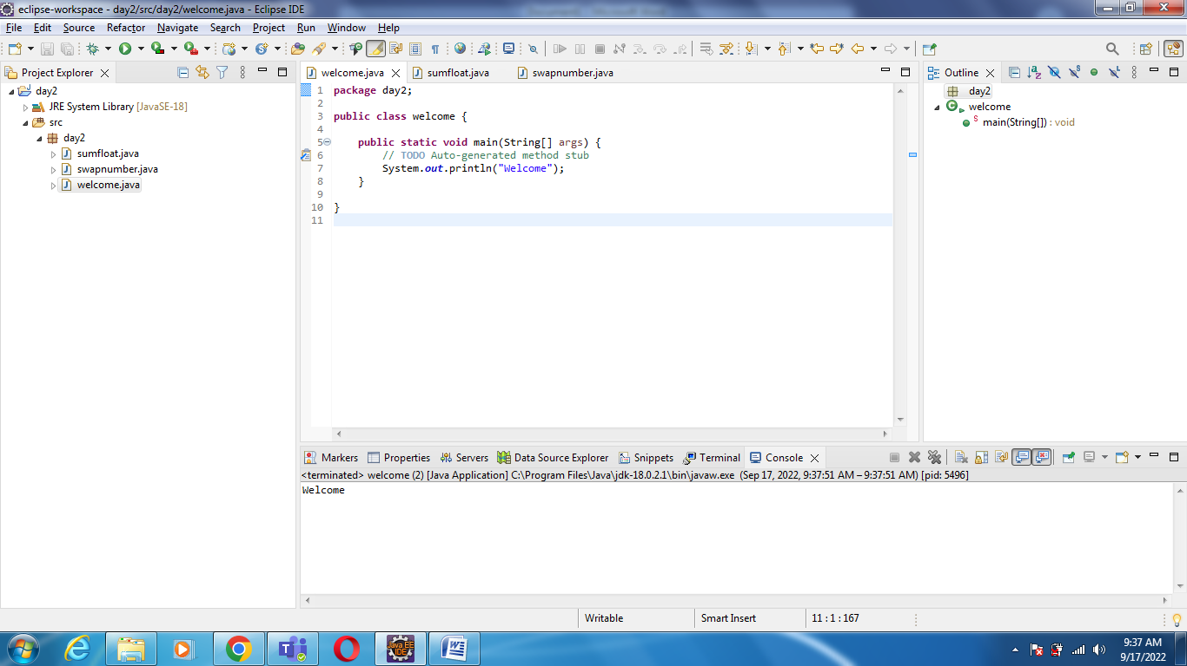

Que 2: java program to print a three float numbers

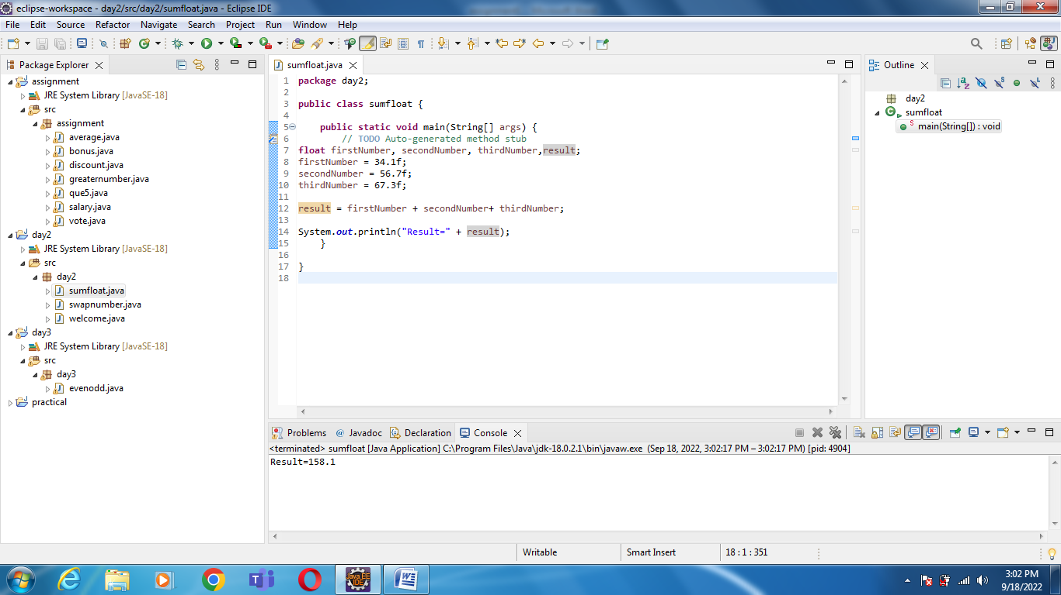

Que 3: java program to swap two numbers

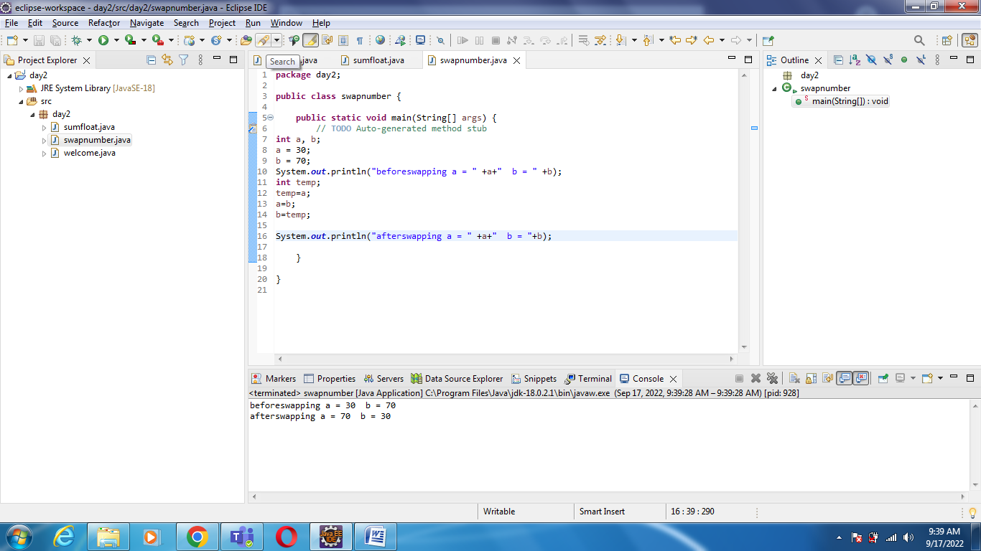

Que 4: wap to check if number is even or odd

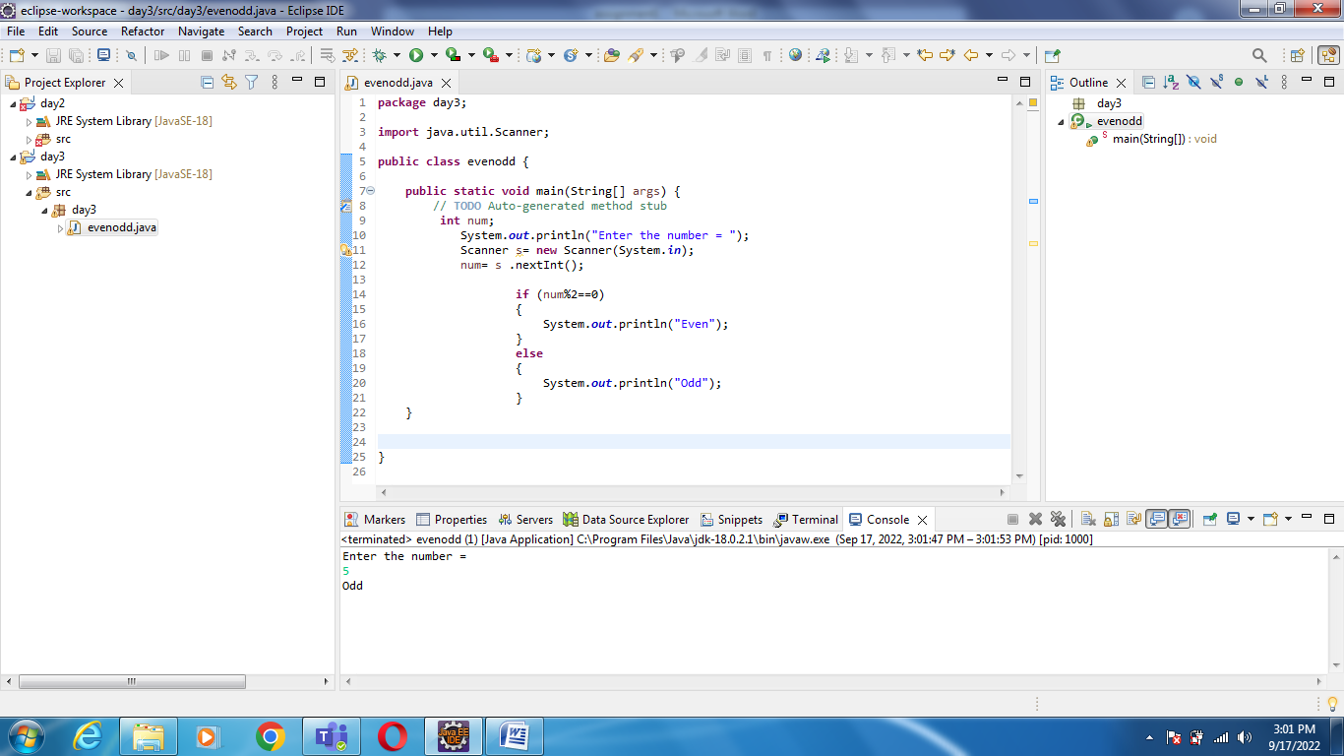

Que 5: wap to check from three given number that whether a number is greater than or equal to20

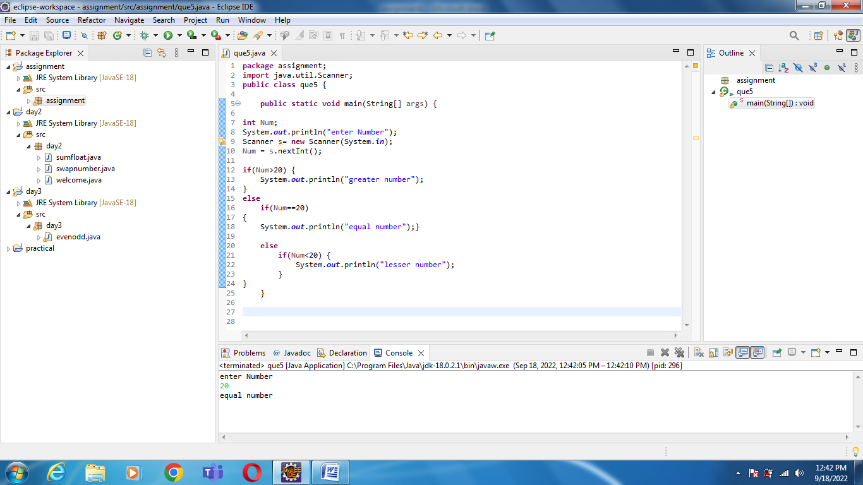

Que 7: wap to check if sales of a person is greater than 10000 then eligible for bonus else not eligible calculate bonus as 20% of sales

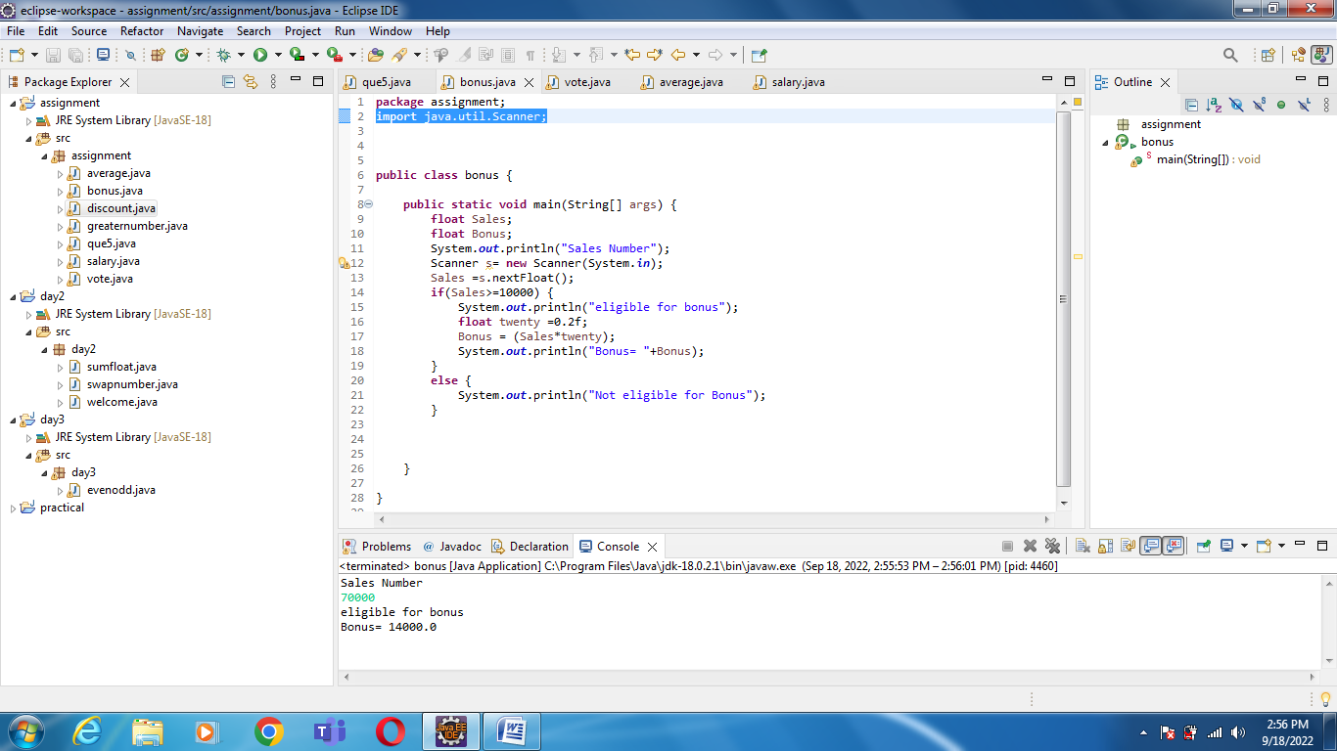

Que8 wap to check if two given integer value is in range of 18 & 100 print eligible for voting else not eligible

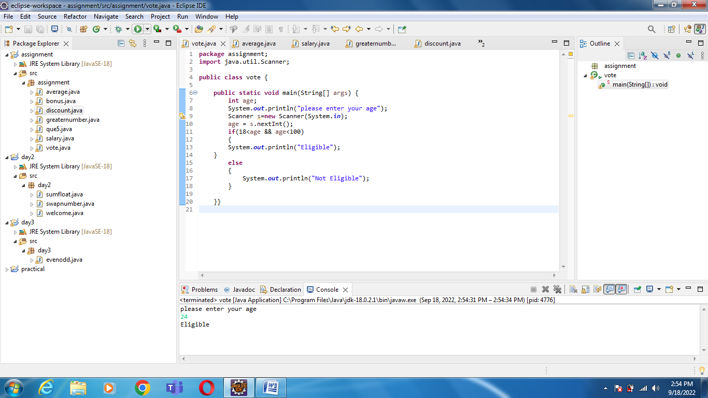

Que 9: wap to give average of given five subjects marks of students and check if average>=40 print PASS else FAIL.

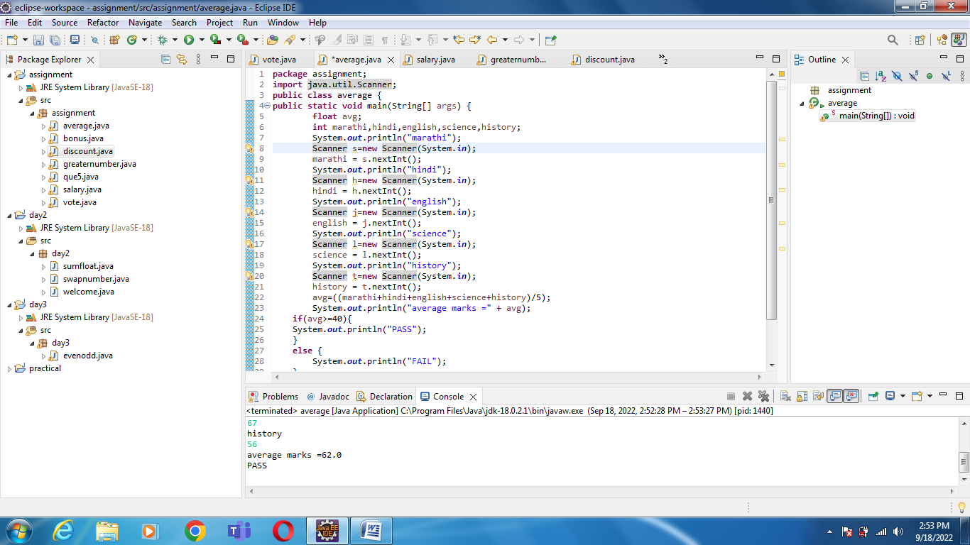

Que 10: wap to ask name, age and salary of an employee and print on console

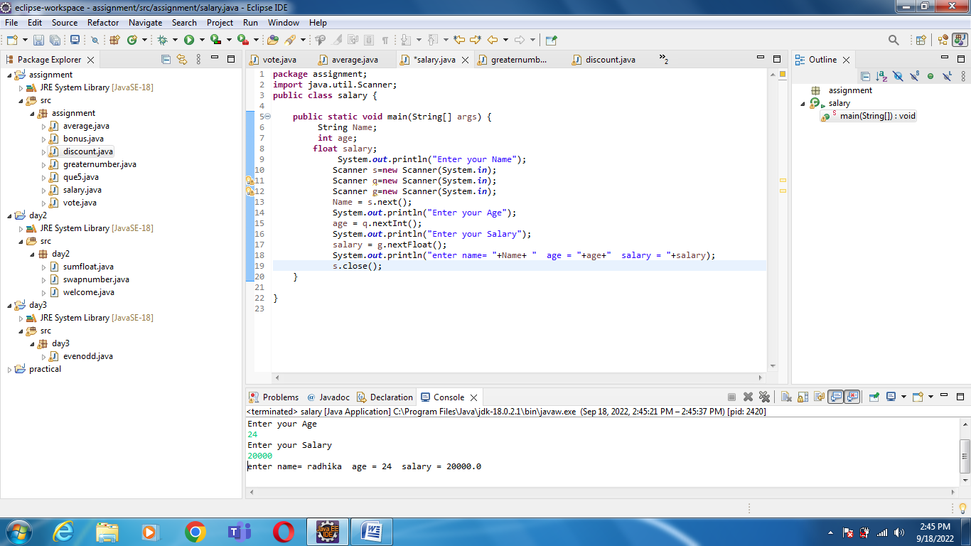

Que 11: wap that ask two numbers from user and print greater number among two

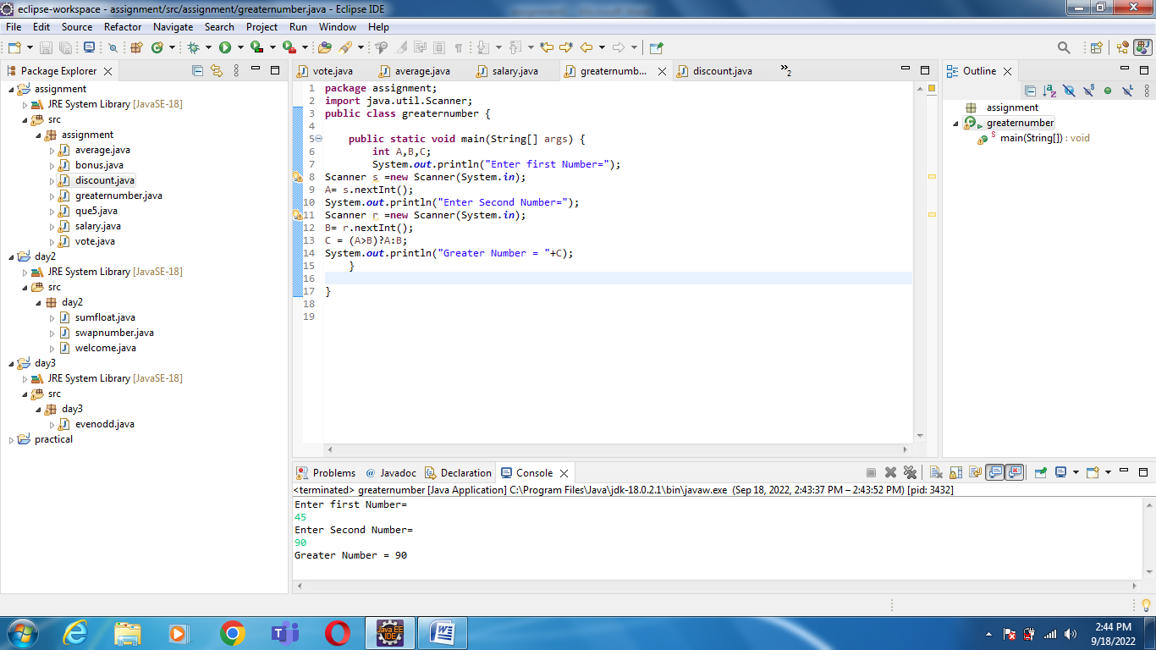

Que 12: wap to ask product name and product name and price of product from user and calculate discount. i. e. if price>2000 then discount is 10% of price else discount is 7% of price

